30.71: a) Immediately after  is closed, 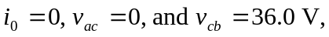 since the inductor stops the current flow.
b) After a long time, 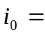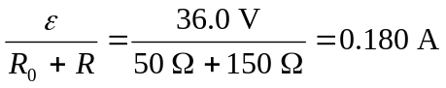,
c) 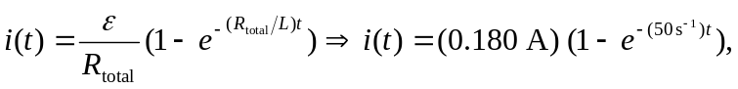
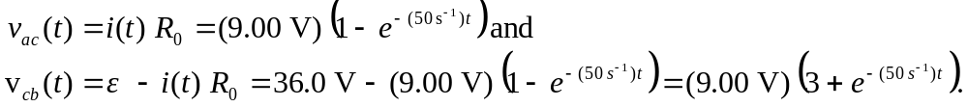
Below are the graphs of current and voltage found above.

